MSIS 638

Case 4.3a

Jia Liang Ma

1. Refer to the Fantasia Restaurant example discussed in the text. Based on the given payoffs and probabilities, the Boston location is the best alternative with an expected payoff of 105. If the Fantasia Restaurant chooses the Boston location, what will be its *real* profit?

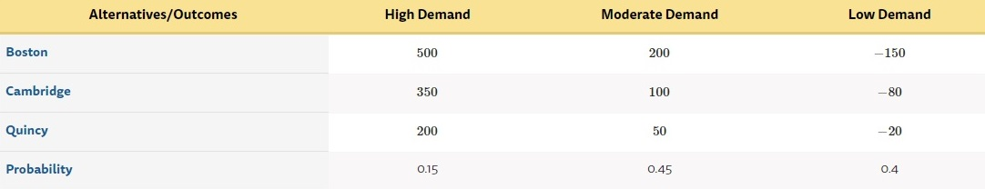

Best EP = 105, which is $105,000

For real profit of this case, the expected approach provided only roughly probability payoff for Fantasia Restaurant. To determine the total profit and loss for this restaurant would be more complex. For example, even we take expected payoff of perfect information (EVPI) into account, we cannot fully make sure that the EPPI is the best or the expected opportunities loss is 0. So, in this case, the real profit will be increase or decrease then the expected payoff when choosing the Boston location.

1. Explain, in your own words, how mathematical expectation is related the possible *real-world* outcomes you mentioned in part (a). Note that we want a relationship in the *real-world*, **not** a relationship in an abstract sense in the mathematical world (e.g., the expected payoff is the weighted average of possible payoffs).

Hint: what happens if the Fantasia Restaurant could do the experiment (i.e., choosing the location) many times, e.g., 100 times? What would be the payoff in each of those experiments? What would be the average of those 100 numbers?

1. The real profit will be dependent on different scenarios, and even the fluctuation commodity price and human resources. For example, under the pandemic period, the uncertainty will be more to consider. In other words, the Boston location might not turn out be the best choice but based on the information given. The given probability also will have a significance coefficient with the outcome. So, the approach may provide a big picture of the payoff solution yet still need to take many factors into account. The connection between real world and mathematical expectation is through the assumptions to verify the particular outcomes, this will benefit the solution of real-world problem by fixing the factors and the probability values from time to time.
2. If the Fantasia Restaurant can do many times experiments (ex, 100 times), then they will have a more accuracy sample data for the test. This will help the restaurant using a better EPSI than before. Also, the expected payoff may be slightly change based on the experiments, revising the expected value with a precisely probability.
3. What would be the payoff in each of those experiments?

The payoff in each experiment would be from slightly different to outliers. Based on the weighted criterion methods and different parameters taken in sensitivity analysis, the fixed probability may influence the outcome. Without changing the incidents above, the experiment outcomes might be the same.

1. What would be the average of those 100 numbers?

The average of those 100 numbers would be slightly increase or decrease than the current one due to the practical experiments.

1. Given that the Fantasia Restaurant is choosing the location only *once*, do you still think they should use the mathematical expectation approach? Why?

In my point of view, if we can choose only once for Fantasia Restaurant, then using only expectation approach would be risky. With different scenarios, the optimal choice and probability might change. In this way, Boston might not be the optimal choice.

Back to the case, if Fantasia Restaurant chose the Boston location, they may receive the best profit by using the weighted criterions. In the fact of that, the probability will cause the directly to the outcome. Even though, I believe there is a good way to use the expected method. By extending the complexity of the method, we can have more details about the problem before making the decision. Through the probability, the outcome may be available for user to avoid risk or know more information about the expected profit in different areas.